**GMAIL INBOX FUNCTIONALITY**

1. **Verify login functionality**

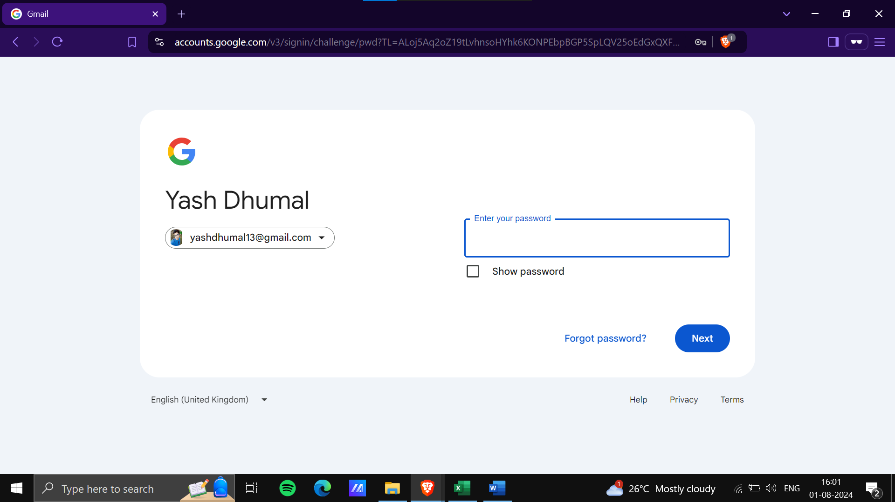

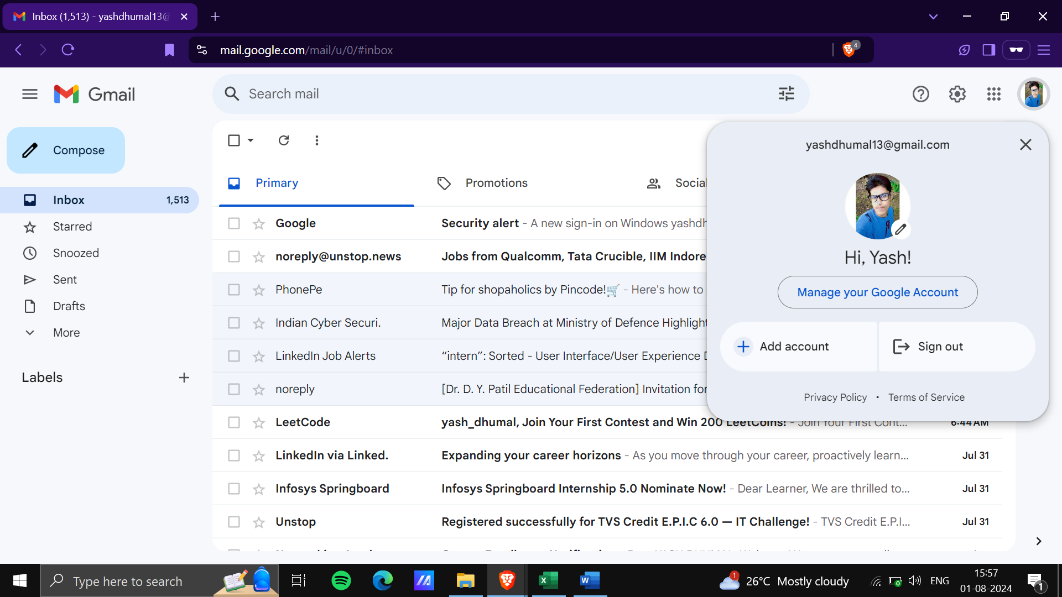

1. **Verify email compose functionality**

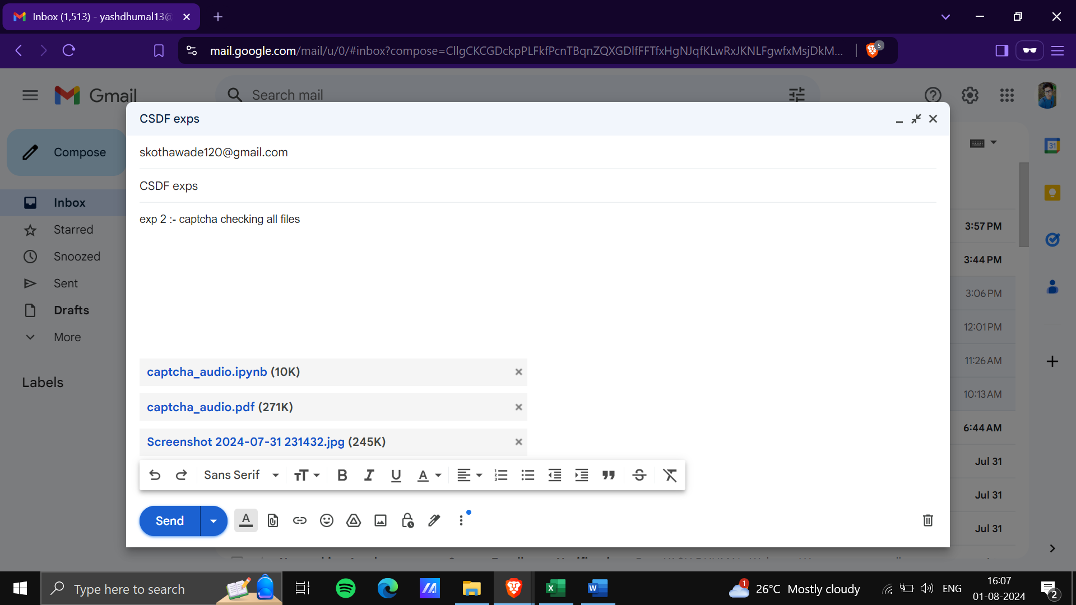

1. **Verify email deletion functionality**

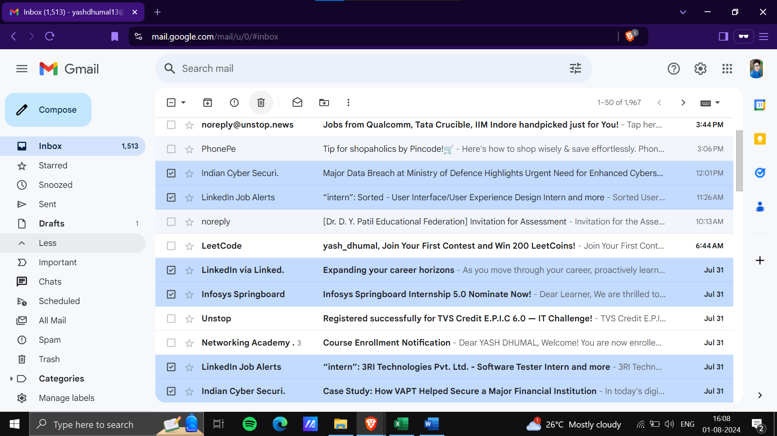

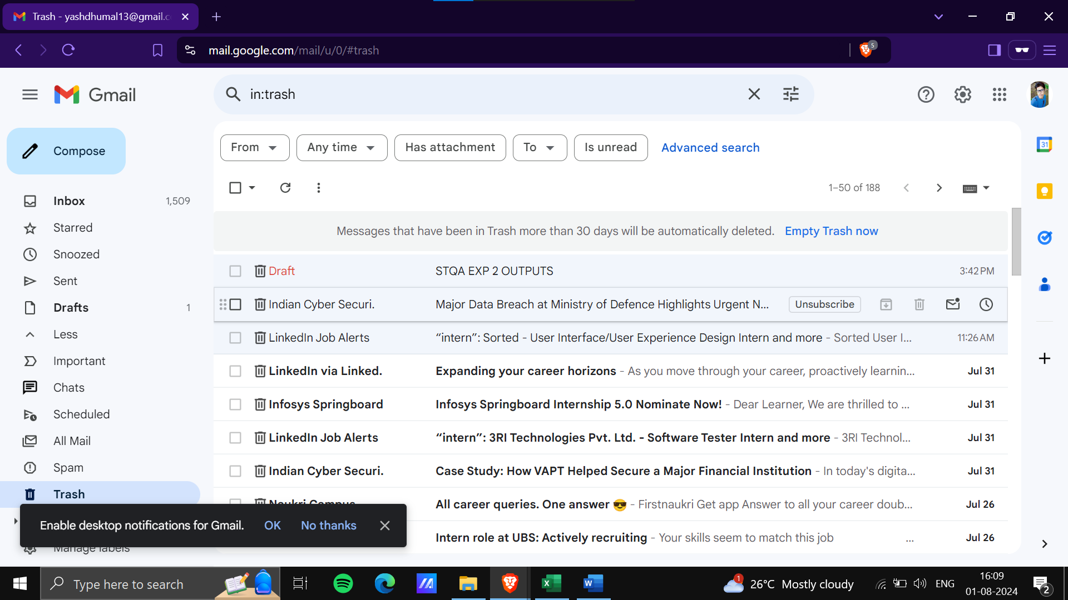

1. **Verify email marking as read/unread**

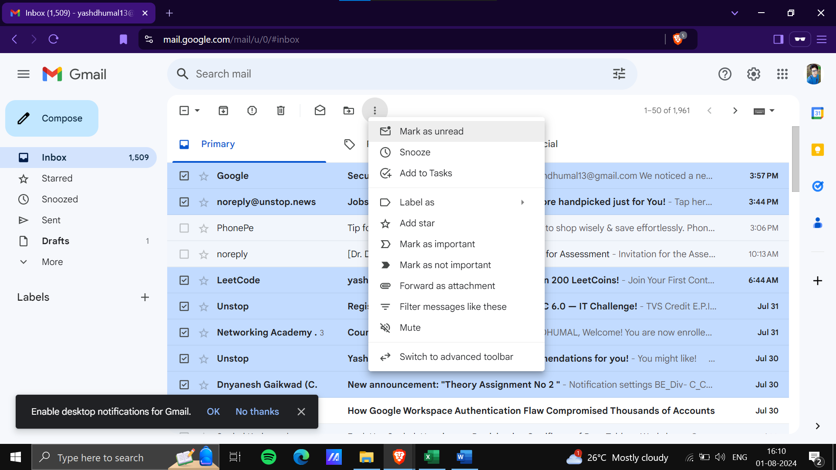

1. **Verify email archiving functionality**

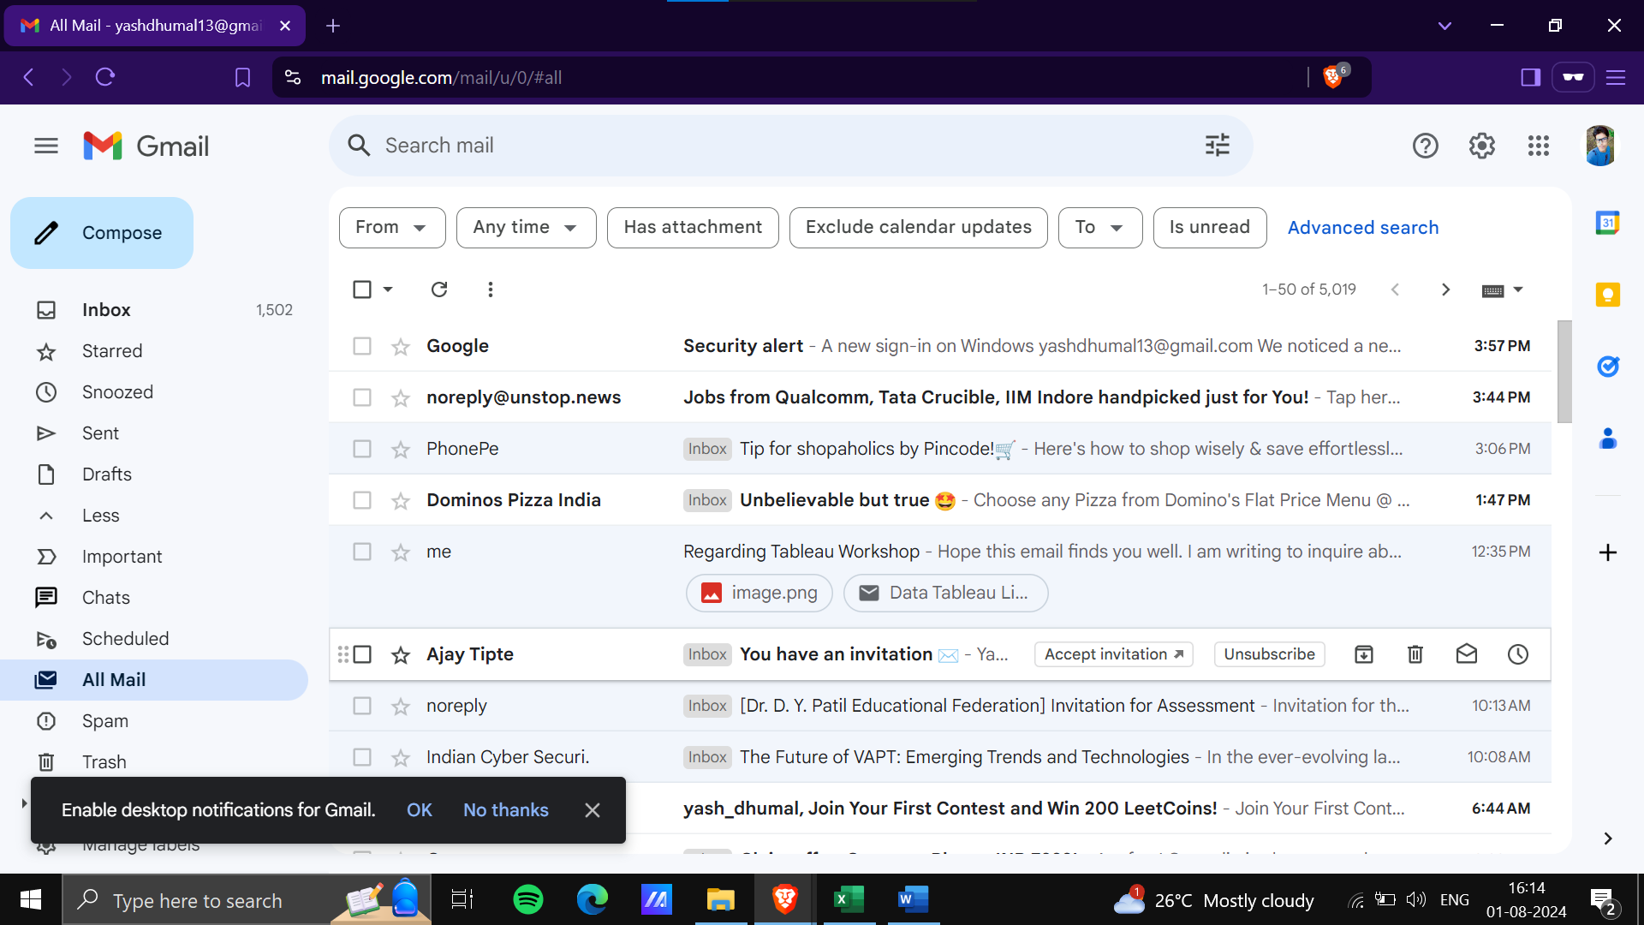

1. **Verify email labeling functionality**

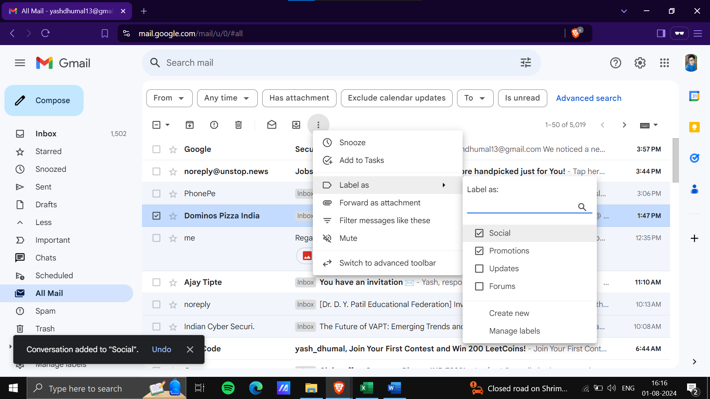

1. **Verify email search functionality**

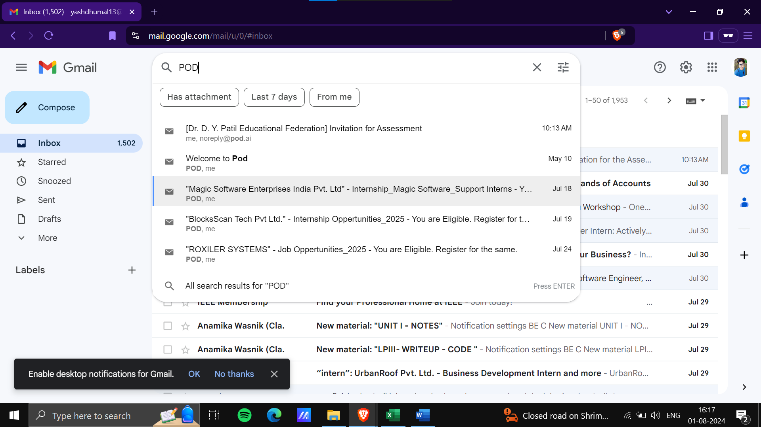

1. **Verify email sorting functionality**

